Nombre: ____________________________ Bloque: ________ Fecha: _______________________
Unidad 1 – La cultura – Costa Rica
Instrucciones: Fill out the following notes sheet based on the cultural activities online. This follows the online activity in order by section. Make sure to hold on to this paper to study, as this information will be part of the exam! This can also be used as a backup should you lose internet connection while working.

Vocabulario Importante:
Write the English meaning of the following words.
- Una mariposa: ____________________________
- Un volcán: ____________________________
- Un equipo de fútbol: ____________________________
- Reservas protegidas: ____________________________
- Los colibríes: ____________________________
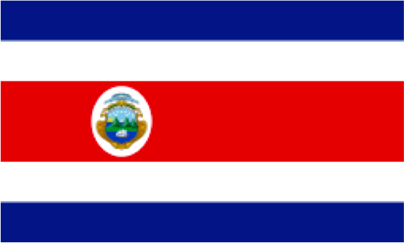
- Una carreta: ____________________________
- Unas cataratas: waterfalls

Información general:
- Capital of Costa Rica: ____________________________
Colors of the Costa Rican Flag: ___________________
________________________
- Typical food: ____________________________________
- Ocean to the west (oeste): ____________________________
norte
- Sea to the east (este): ____________________________
- Country on the northern border: ____________________________
oeste
este
- Country on the southern border: ____________________________
- Is Costa Rica typically known for warm or cold weather activities? _____________
sur (sud)
- Costa Rica is a country located in _______________________.

Los Ticos:
- Another word for costarricense/Costa Rican is: ____________________________
- Where does the term Tico come from? _______________________
- What is the name of the soccer team in Costa Rica: __________________

Las Aguas Termales:
- What are “Aguas termales”?: ____________________________ (¡hace calor!)
- In the resort (resorte) Tabacón en Arenal you can see the active ________________, Arenal.
La Naturaleza de Costa Rica:
- In Costa Rica there are a lot of gardens and reserves where nature is protegida or _____________.
- In Jardín de la Cataratas La Paz you can see mariposas or __________________ at an observatory, colibríes or ______________________, orquídeas or _________________, and five different cataratas or ___________________.
- A famous butterfly species from Costa Rica is the ________________________.

Las carretas de Costa Rica:
- The most well-known artesanía or handicrafts from Costa Rica are brightly painted wooden ________________ called carretas.
- The carretas used to transport ___________________, but now are mostly decorative.

Pura Vida y Adrián Gómez:
- Adrián Gómez, a famous Costa Rican artist, frequently uses the themes of children and _____________.
- "Pura vida" is a popular phrase used in Costa Rica to greet people (saludar a la gente) and respond to the question ¿Cómo estás?. It reflects the Costa Rican of optimism, tranquility and _______________ in life.

Jeannette Carballo:
- In the painting (Familia en el Volcán Arenal) by the Costa Rican artist Jeannette Carballo, you can see a typical Costa Rican family from the countryside (el campo) standing in front of what landmark? _____________________
- In the painting, the father is holding a radio to listen to the news. The mother is holding one of her daughters. The other daughter has a book and the boy has his books for school.

Costa Rica vs Chile:
- At el Parque Nacional Volcán Rincón de la Vieja in ______________________ you can see an active volcano, walk by waterfalls (cataratas), swim in the hot springs (aguas termales), and see monkeys, iguanas and many birds (pájaros).
- In el Parque Nacional Torres del Paine in ________________ there are volcanoes, glaciers, rivers and lakes, where you can camp, fish, ride bikes, and observe animals such as llamas, condors, and pumas.
- While Costa Rica has mostly summer activities, since it is near the equator, Chile is a very long and narrow country. In the north there is the Atacama Desert. In the south it is cold and you can see _________________!
- The Andes Mountains run through the country of Chile and Chile has great skiing. Because Chile is below the equator (ecuador), its seasons are opposite those of the USA. Therefore, when would you go skiing in Chile? ____________________________
- The Andes Mountain range passes through which country? ______________________

